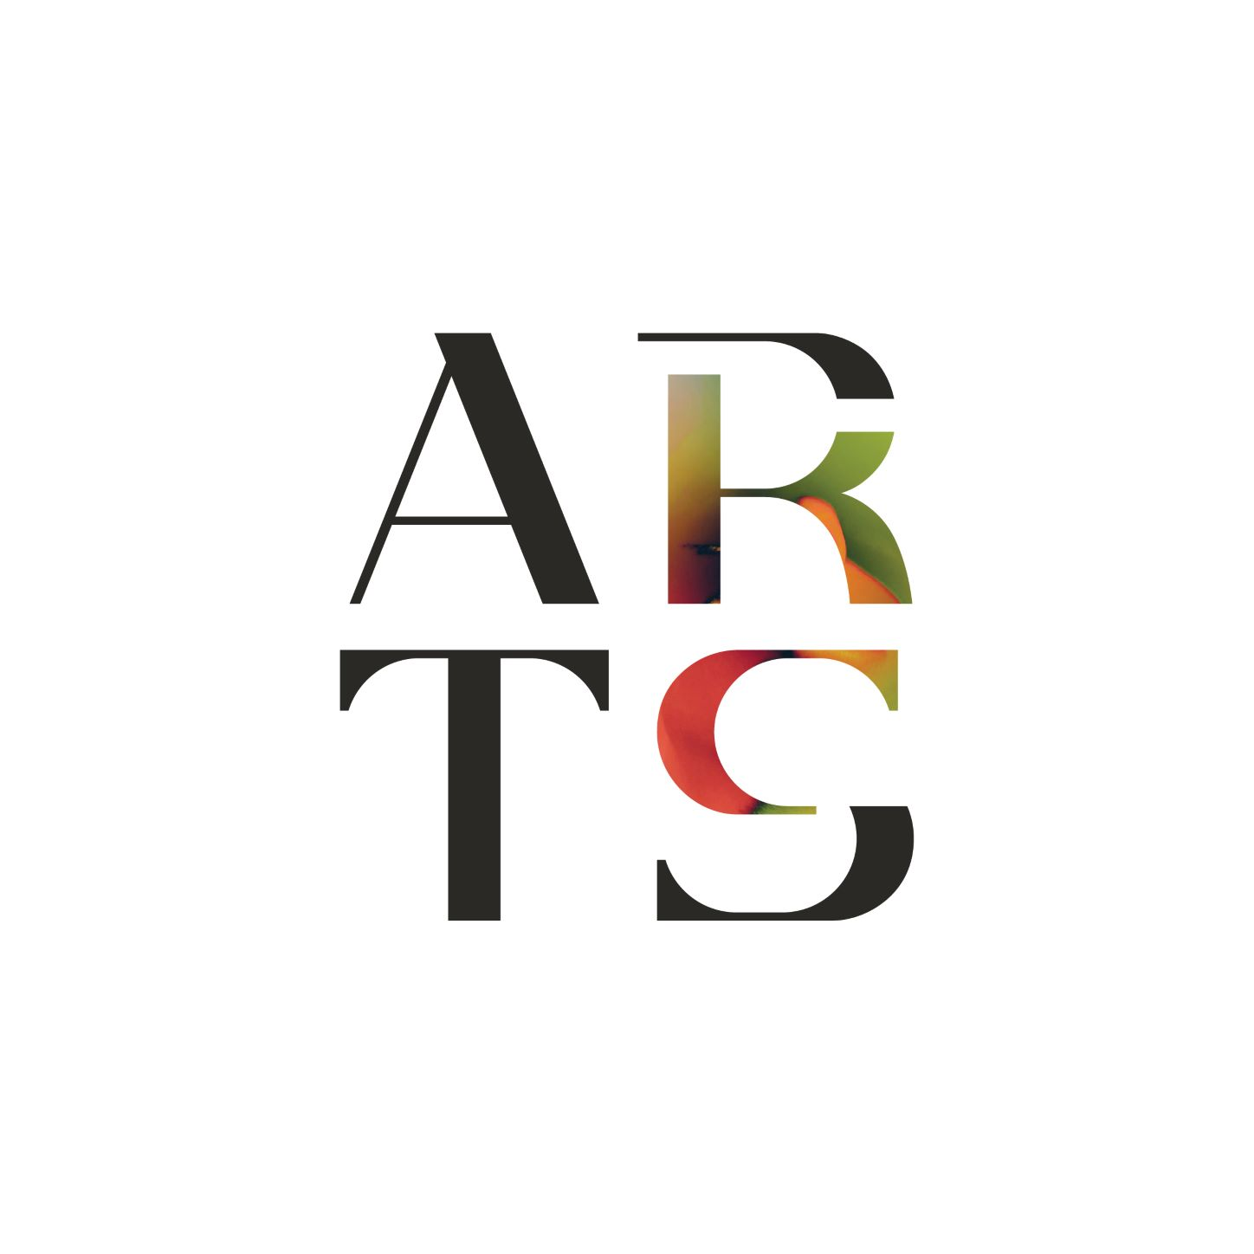

**2025 COMMUNITY GALLERY APPLICATION**

*The gallery application must be completed and submitted online at* [*https://artskc.org/community-gallery-program/*](https://artskc.org/community-gallery-program/)*. This application document is for reference only.*

**Name (first and last)\***

**Pronouns\***

**Name of organization or business (if applicable)**

**Website\***

**Email\***

**Phone\***

**Address\***

**Which category do you or your organization fall into?\***

For-profit local business

Government entity

Nonprofit organization

Individual artist

Other

**What are your ideal activation dates between May and November 2025. Are there any months you would be unavailable to participate in the program?\***

**"Please share your vision for activating the ArtsKC Gallery space. Consider the following: What are your goals? How will you activate the space? (First Fridays, workshops, events, etc.) How will this benefit you/your organization/the broader community? Are you prioritizing empowering underrepresented voices, connections between arts and health, accessibility, or arts education? How so? Who else is involved? How will you market your activation of the space to the**

**public? Where applicable, include details on how many pieces will be included, technology needs and gallery layout needs (wall space only, pedestals, furniture, etc.)"\*** (Max. 600 words)

**Describe how your programming in the space will be accessible for people with disabilities. (reference website resources)\*** (Max. 250 words)

**For individual artists only, please provide a resume/CV and artist statement/bio.** (Max. file size: 512 MB.)

**Please provide a short summary about your proposal for ArtsKC to use in potential announcements, promotion and fundraising. This summary may be changed or shortened by ArtsKC Staff as needed for social media or other purposes.\*** Follow this outline using information from your application: Your name/organization, type of art, what you plan to do, why, with whom, and how.

**Please include one image for ArtsKC to use in public representation of your project, if you are selected to participate.\*** (Max. file size: 512 MB, Max. files: 3.)

By uploading this image, you grant ArtsKC permission to use it publicly on social media and other promotional items. Images of the work itself, or of you working on the project in your studio or other creative space are best. You can include images that are already included in this application. In this case, please upload it again. Please do not use images that have large amounts of text or writing, as text-based images are inaccessible for Screen Readers and other accessibility tools.

**The following section is optional.**

One of the many well-recognized benefits of the arts is their power to bring together people of diverse cultures, backgrounds, ethnicities and socio-economic circumstances. As part of our commitment to be more equitable, and to evaluate our outreach efforts as we strive to be a model of equity, we are gathering specific information from our applicants. The following questions are intended to help us learn more about the artists that reach out to us, and are OPTIONAL. Answers to these questions are private and are not shared with the general public. Answers to these questions do not influence the outcome of your application. If you are applying on

pdabehalf of a small group of artists, choose answers that represent yourself. If you prefer not to answer these questions, scroll to the bottom of the application to submit.

**Age range**

18-24

25-34

35-44

45-54

65-74

75+

**Gender (check all that apply). If you chose Other / Prefer to self describe, please write in the next box.**

Female

Male

Non-binary / Third Gender

Other / Prefer to self describe

**Do you consider yourself to be Transgender?**

Yes

No

Prefer not to respond

**Ethnicity (check all that apply). If you chose Other, please write in the next box.**

American Indian or Alaska Native

Asian

Black or African American

Caucasian

Hispanic or Latinx

Native Hawaiian or Other Pacific Islander

Prefer not to say

Other

**Veteran status**

Yes

No

Prefer not to say

**Of the options below, how do you identify?**

Disabled

Non-disabled

Prefer not to say

This is a voluntary self-identification of disability.

**Sexual Orientation**

Asexual

Bisexual

Gay

Heterosexual or Straight

Lesbian

Pansexual

Queer

Prefer not to say

Other